BASH SCRIPTING

* To find out where is your Bash interpreter located.

$ which bash

This command reveals that the Bash shell is stored in /bin/bash.

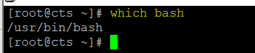

* create a file called hello_world.sh.

$ vi hello_world.sh



Code to be excuted in hello_world.sh

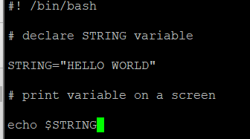

Save using :wq!

* Navigate to the directory where your hello_world.sh script is located and make the file executable:

$ chmod +x hello_world.sh





* Now you are ready to execute your first bash script:

$ ./hello_world.sh



**Simple Backup bash shell script**

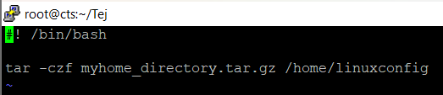

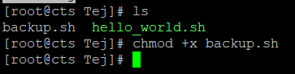

**Variables in Bash scripts**

Simple bash variable $STRING and print it on the screen (stdout) with echo command.

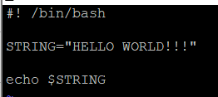

The result when we execute the script:

